Lagged cross-correlation: NZDUSD and USDCHF
Method 12 / daily log returns / K_max=10 / Alpari D1 full available history

Study setup
Logical pair: NZDUSD , USDCHF
Broker symbols: NZDUSD_i , USDCHF_i
Snapshot: 2026-11-03_majors_alpari_D1
Timeframe: D1
Matched return window: 1999-01-05 to 2026-11-02 (UTC bar dates)
Matched return count n: 7185
Dropped unfinished last bar dated 2026-11-03 UTC after a tick-volume check against the prior complete day.
Lag definition: rho_X->Y(k) = Corr(x_t, y_{t+k}) on matched D1 bars
K_max = 10; headline lag k = 1 (both directions)
Complete matched rows (Excel): NZDUSD-USDCHF_Lagged_D1.xlsx
Complete matched rows (HTML table): NZDUSD-USDCHF_Lagged_D1_data.html

Method carried forward
Lagged cross-correlation measures Pearson correlation between matched daily log returns of close, ln(close_t / close_t-1), after shifting one series forward by k bars on the matched panel. Quotes are not inverted. rho_{X->Y}(k) = Corr(x_t, y_{t+k}) with n_k = n - k. K_max = 10 is fixed before estimation. The headline is the pre-specified lag k = 1 in both directions. k = 0 is the same-bar side check. The lag inside 1..10 with the largest absolute rho is stored as a descriptive column only; it is not a selected result. This is a linear screen, not proof of forecast edge, economic cause, or a trading signal.

Results (headline k=1)
rho_NZDUSD->USDCHF(1): 0.002509 (n=7184)
95% Fisher interval NZDUSD->USDCHF: [-0.020617, 0.025632]
rho_USDCHF->NZDUSD(1): 0.001692 (n=7184)
95% Fisher interval USDCHF->NZDUSD: [-0.021434, 0.024816]
Same-bar rho(k=0): -0.393600
Largest |rho| among k=1..10 (descriptive only, not selected): NZDUSD->USDCHF k=5 rho=-0.021145; USDCHF->NZDUSD k=2 rho=-0.031591

CCF table
k | rho_NZDUSD_to_USDCHF | n_NZDUSD_to_USDCHF | rho_USDCHF_to_NZDUSD | n_USDCHF_to_NZDUSD
0 | -0.39359959 | 7185 | -0.39359959 | 7185
1 | 0.00250908 | 7184 | 0.00169167 | 7184
2 | 0.00552629 | 7183 | -0.03159074 | 7183
3 | 0.00154682 | 7182 | 0.02545446 | 7182
4 | -0.00857126 | 7181 | -0.00010817 | 7181
5 | -0.02114498 | 7180 | 0.01932619 | 7180
6 | -0.00327834 | 7179 | -0.02083318 | 7179
7 | -0.01567655 | 7178 | -0.00051052 | 7178
8 | -0.01521585 | 7177 | -0.00104924 | 7177
9 | 0.01938981 | 7176 | -0.00887317 | 7176
10 | -0.00346029 | 7175 | 0.00258024 | 7175

Conclusion
At the pre-specified lag k=1 for NZDUSD and USDCHF, rho_{NZDUSD->USDCHF}(1) = 0.0025 (n=7184) and rho_{USDCHF->NZDUSD}(1) = 0.0017 (n=7184). Same-bar rho(k=0) = -0.3936. Largest |rho| among k=1..10 is descriptive only: NZDUSD->USDCHF at k=5 (-0.0211); USDCHF->NZDUSD at k=2 (-0.0316). This is a linear screen, not forecast proof or a trading signal.

Charts
Daily closes

Daily log returns

CCF both directions k=0..10
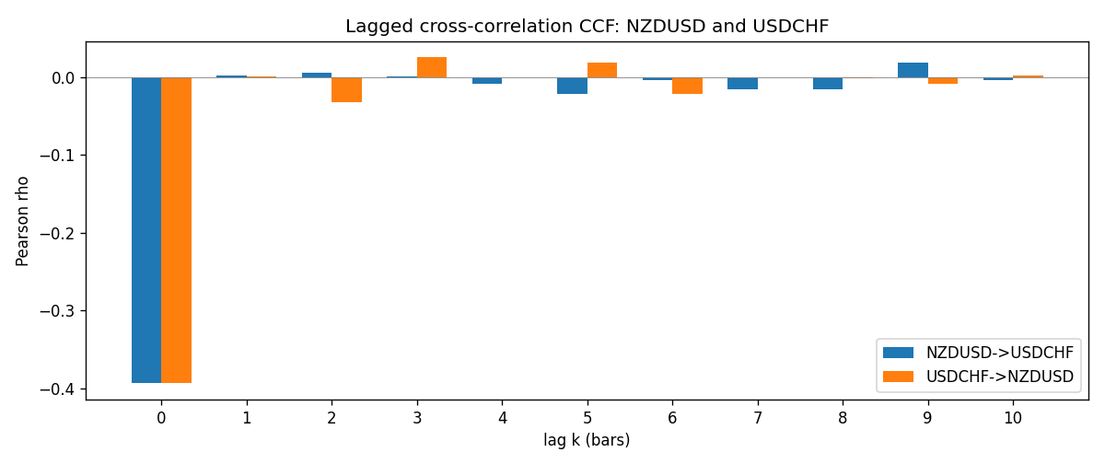

Data report
Every matched row is stored in the sibling Excel workbook named NZDUSD-USDCHF_Lagged_D1.xlsx (sheet matched_rows). The CCF sheet holds rho(k) for k=0..10. Embedding all rows as a Word table is impractical; the Word file holds column summaries and the first and last 15 rows.
Columns: time, NZDUSD_open, USDCHF_open, NZDUSD_high, USDCHF_high, NZDUSD_low, USDCHF_low, NZDUSD_close, USDCHF_close, NZDUSD_tick_volume, USDCHF_tick_volume, NZDUSD_spread, USDCHF_spread, NZDUSD_real_volume, USDCHF_real_volume, NZDUSD_log_return, USDCHF_log_return
Column summaries (matched calculation rows)
column | count | mean | std | min | 25% | 50% | 75% | max
NZDUSD_open | 7185 | 0.65641395 | 0.10821881 | 0.3913 | 0.59137 | 0.6684 | 0.72499 | 0.88218
USDCHF_open | 7185 | 1.0976269 | 0.25248305 | 0.72022 | 0.92053 | 0.98988 | 1.2378 | 1.8219
NZDUSD_high | 7185 | 0.66033247 | 0.10871106 | 0.3961 | 0.59478 | 0.672 | 0.72937 | 0.88421
USDCHF_high | 7185 | 1.1029176 | 0.25422469 | 0.73305 | 0.92474 | 0.99353 | 1.2423 | 1.8313
NZDUSD_low | 7185 | 0.65272894 | 0.10781325 | 0.3897 | 0.58811 | 0.66417 | 0.72099 | 0.87988
USDCHF_low | 7185 | 1.0925083 | 0.25089773 | 0.08565 | 0.91719 | 0.98622 | 1.2317 | 1.8121
NZDUSD_close | 7185 | 0.65649284 | 0.10821292 | 0.3907 | 0.59165 | 0.6684 | 0.72502 | 0.8822
USDCHF_close | 7185 | 1.0976163 | 0.25237603 | 0.72025 | 0.92079 | 0.98995 | 1.2379 | 1.8217
NZDUSD_tick_volume | 7185 | 68718.644 | 123140.12 | 16 | 5587 | 33899 | 58511 | 1127682
USDCHF_tick_volume | 7185 | 74335.19 | 113494.16 | 18 | 12810 | 40241 | 70443 | 858589
NZDUSD_spread | 7185 | 30.278775 | 25.647496 | 0 | 9 | 17 | 40 | 80
USDCHF_spread | 7185 | 26.036326 | 24.697816 | 0 | 5 | 16 | 50 | 100
NZDUSD_real_volume | 7185 | 1.6703703e+10 | 8.4983725e+10 | 0 | 0 | 0 | 0 | 2.705649e+12
USDCHF_real_volume | 7185 | 2.3294091e+10 | 8.9133595e+10 | 0 | 0 | 0 | 0 | 1.9331921e+12
NZDUSD_log_return | 7185 | 2.019e-05 | 0.00763908 | -0.07027433 | -0.0042485 | 0.00023717 | 0.00458461 | 0.05966839
USDCHF_log_return | 7185 | -7.205e-05 | 0.00658891 | -0.19545699 | -0.0033516 | 8.095e-05 | 0.00331593 | 0.09051364
First 15 matched rows (selected columns)
time | NZDUSD_close | USDCHF_close | NZDUSD_log_return | USDCHF_log_return
1999-01-05 | 0.5372 | 1.3724 | -0.0018597736 | 0.0039424743
1999-01-06 | 0.5383 | 1.3912 | 0.0020455609 | 0.013605652
1999-01-07 | 0.5417 | 1.3782 | 0.0062963171 | -0.0093883841
1999-01-08 | 0.5414 | 1.3935 | -0.00055396548 | 0.011040268
1999-01-11 | 0.547 | 1.4009 | 0.010290425 | 0.0052963193
1999-01-12 | 0.5441 | 1.3872 | -0.0053157489 | -0.0098275602
1999-01-13 | 0.5387 | 1.3621 | -0.0099742238 | -0.018259701
1999-01-14 | 0.5386 | 1.3588 | -0.00018564931 | -0.0024256692
1999-01-15 | 0.5382 | 1.3834 | -0.00074294208 | 0.01794228
1999-01-18 | 0.5372 | 1.379 | -0.0018597736 | -0.0031856384
1999-01-19 | 0.5382 | 1.3789 | 0.0018597736 | -7.2518946e-05
1999-01-20 | 0.5404 | 1.3889 | 0.0040793678 | 0.0072259871
1999-01-21 | 0.5426 | 1.3836 | 0.0040627941 | -0.0038232689
1999-01-22 | 0.5361 | 1.3834 | -0.012051689 | -0.0001445609
1999-01-25 | 0.5342 | 1.3868 | -0.0035504102 | 0.0024546976
Last 15 matched rows (selected columns)
time | NZDUSD_close | USDCHF_close | NZDUSD_log_return | USDCHF_log_return
2026-10-13 | 0.56127 | 0.83244 | 0.0047326165 | -0.0024955621
2026-10-14 | 0.55918 | 0.83489 | -0.0037306483 | 0.0029388325
2026-10-15 | 0.56185 | 0.82676 | 0.0047634855 | -0.0097855323
2026-10-16 | 0.56509 | 0.82377 | 0.0057501001 | -0.0036230826
2026-10-19 | 0.56616 | 0.82677 | 0.0018917133 | 0.0036351779
2026-10-20 | 0.56827 | 0.8246 | 0.0037199341 | -0.0026281224
2026-10-21 | 0.57003 | 0.82427 | 0.0030923331 | -0.00040027413
2026-10-22 | 0.56815 | 0.82032 | -0.0033035227 | -0.0048036381
2026-10-23 | 0.56991 | 0.82497 | 0.0030929853 | 0.005652514
2026-10-26 | 0.56826 | 0.82649 | -0.0028993932 | 0.0018407959
2026-10-27 | 0.56811 | 0.82865 | -0.00026399852 | 0.0026100526
2026-10-28 | 0.56261 | 0.82781 | -0.0097283914 | -0.0010142111
2026-10-29 | 0.56296 | 0.82379 | 0.00062190714 | -0.0048680164
2026-10-30 | 0.56307 | 0.82438 | 0.00019537668 | 0.00071594559
2026-11-02 | 0.56161 | 0.81851 | -0.0025962955 | -0.0071459744

